* What is your style?
  + I like sticking to a schedule and knowing what I am supposed to do before I do it. I am not a fan of sudden shifts in the schedule unless I expect it to happen because then I can mentally prepare for it.
* When do you like people to approach you and how?
  + I don’t mind people approaching me in any way. The biggest thing that I dislike is when I make it clear that I am busy and could talk in a bit, yet someone is still trying to get me to do something or say something. People can yell my name, call me, or even text me. Honestly, whatever people need to do to get a hold of me works for me.
* What do you value?
  + I value it when people are not afraid to try new things or try something different. If it does not work, move on and try something else.
  + I also value passion, dedication, and an open mind.
* How do you like people to communicate with you?
  + I prefer receiving messages on platforms like MS teams, Slack, or Discord. That way, I can see them whenever I am free or have the application open which is quite often.
* How do you make decisions?
  + I make decisions pretty quickly, based on info that I know, and things that I can speculate. I don’t put a ton of thought into decisions, but I put enough in to not try something completely arbitrary.
* How can people help you?
  + People can help me by making sure I don’t miss any important details. I move pretty quickly and might forget some.
  + They can also help me by telling me what they want from me or telling me what I can do to help them.
* What will you not tolerate in others?
  + Impatience with me. That is not to say people can’t expect things from me in a timely manner, rather what I mean is that there is no need to nag me to do something more than once. If I have said I am going to do it, I am going to do it.
* Health, work, play, love
  + 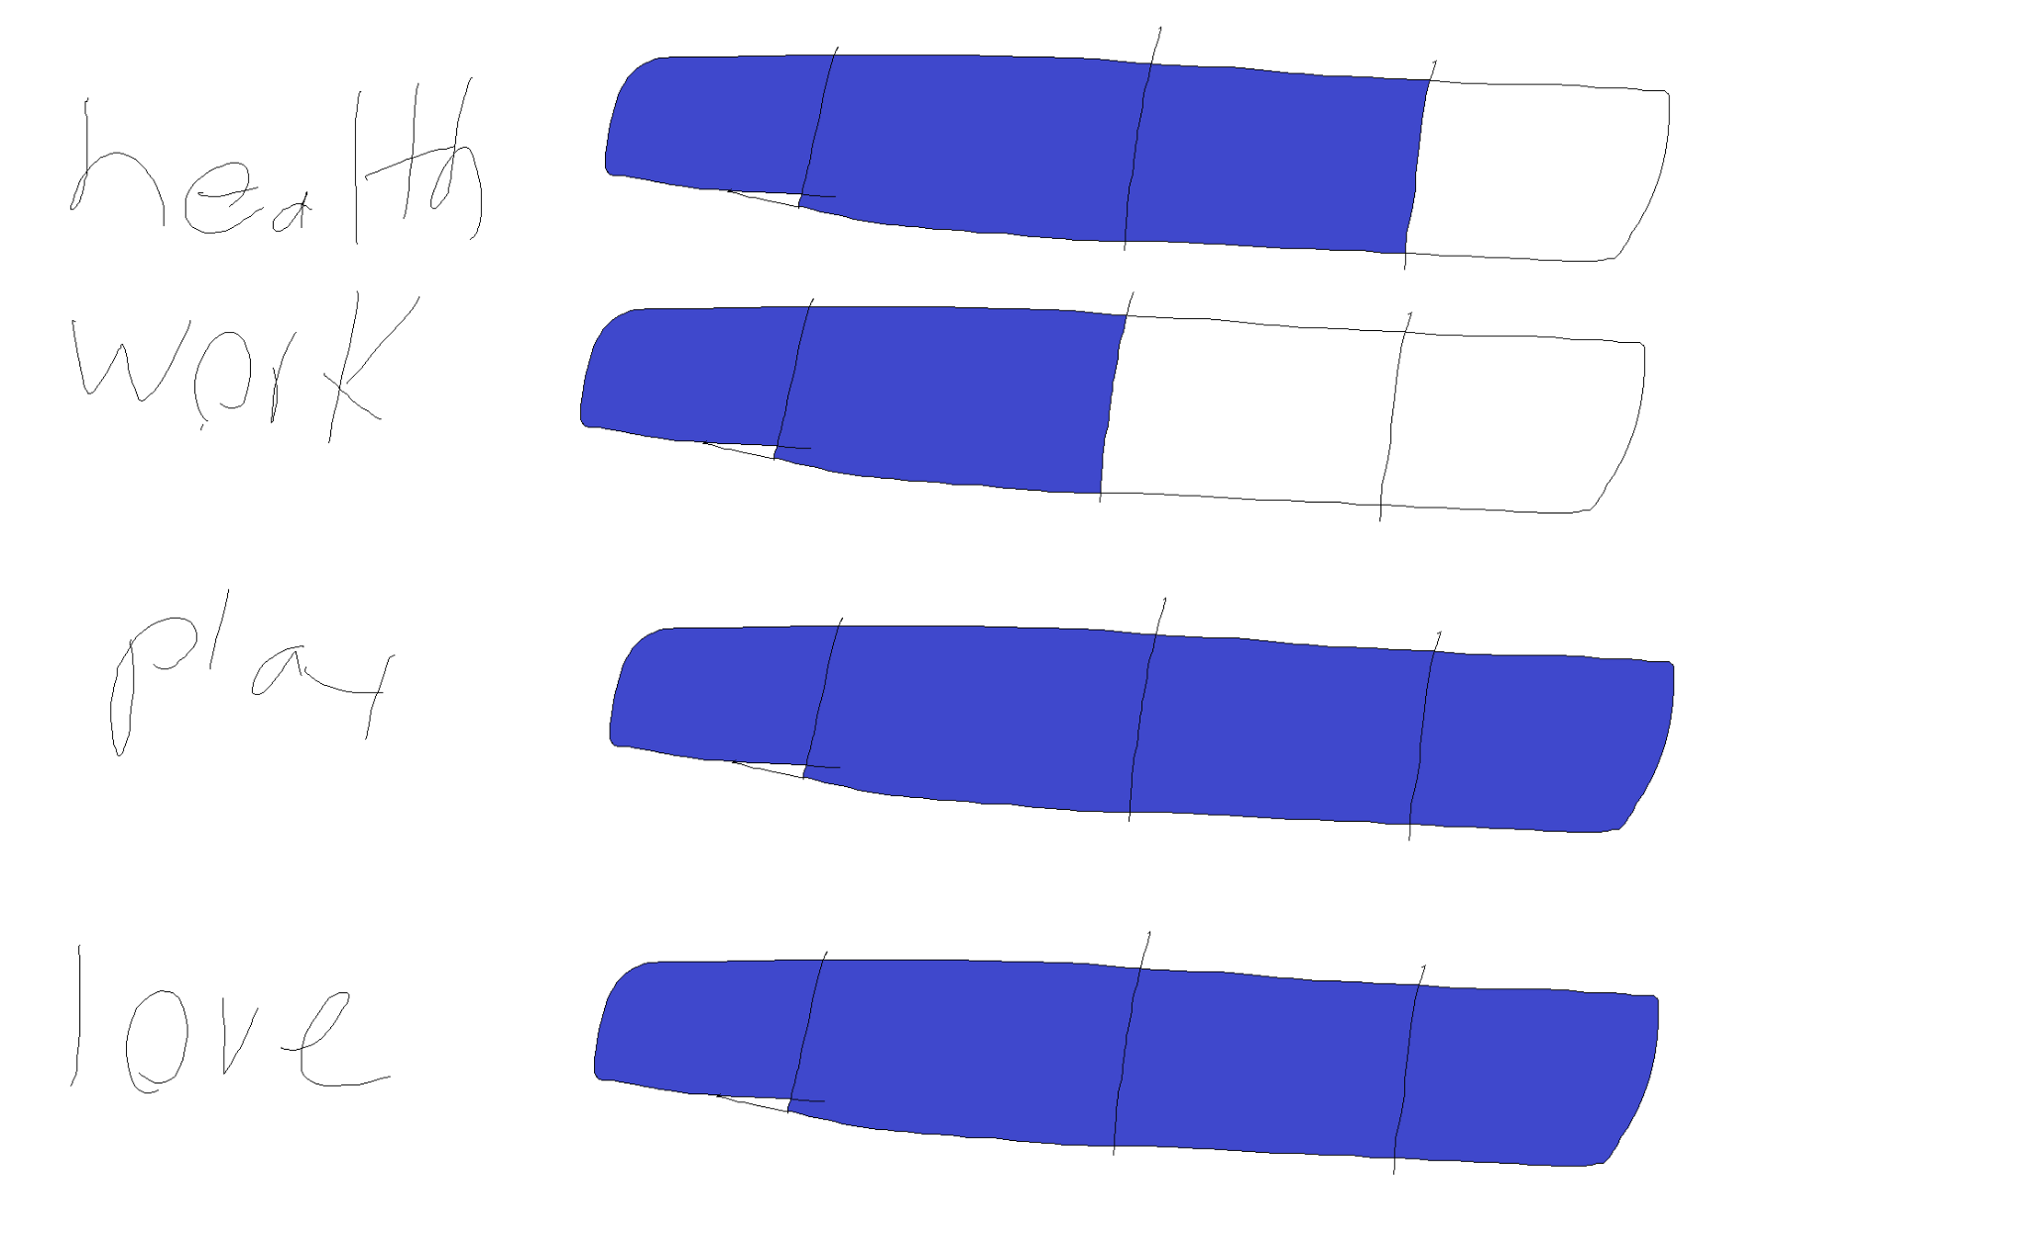
  + My work could be better. It’s not necessarily that I don’t like my work or have a problem with it, I would just need to be more motivated to do it! I think it could be a circle of influence problem. My coworkers aren’t the most exciting to be around, though that may be because it is 4:30 in the morning.
* Compass - Workview and Lifeview
  + Workview
    - I think work is important because it helps us develop skills that we were born with as long as we find out what we like to do. It is also a nice way to use those skills to help others and make some money at the same time. Working means taking some time and doing things you need to do to make money, instead of things you might rather want to do. As mentioned before, money can be a part of it. Money makes it possible for us to buy things that help us live, so it is pretty important.
  + Lifeview
    - I think we are here because we are meant to be something greater than we were. We learn in this life and we can choose to become better. What is the point of learning though, if there is nothing after this life? I choose to believe in God for this reason, and more, but this one, in particular, relates well to my lifeview. God gives all good things but also allows us to experience not-so-good things in order for us to learn to rely more on Him. We are placed in families and create relationships because those relationships can last for all eternity and we are not meant to be alone I don’t think.
  + Where do they complement each other?
    - In both of them, I mention other people. I work to help others and support my family and I believe family relationships and relationships with others are important.
  + Where do they clash?
    - I’m not sure if these clash with each other, but sometimes the workview may take priority over the lifeview which I don’t think it should.
  + Does one drive the other? How?
    - I need money to support my family and lifeview. One way to get money is working.
* Time journal
  + Entries May 23 and 24):
    - Provide energy:
      * I watched my brother graduate high school
      * I drove back
      * I hung out with a good friend
      * I have a car now
      * Sleeping
    - Did not provide energy:
      * Waking up early
      * Driving to Utah
      * Doing math homework
      * Going to bed early
      * Going to work
  + Historical Data:
    - Past month
      * Hanging out with friends increased engagement.
      * Starting a job increased engagement
      * Going to a bunch of job interviews decreases energy
      * Doing homework in general decreases energy
  + Hanging out with a good friend gave me a lot of energy, but spending time with strangers seems to have the opposite effect. How interesting.
  + Doing my math homework always drains my energy because there is always a ton of problems!
  + Not really any surprises there.
  + AEIOU
    - Activities I did were mostly structured. I have a schedule I try to stick to daily.
    - The environment depends on the thing I am doing. Homework, for example, I usually do mid-day at my apartment, or if I decide to have lunch on-campus I’ll do it there.
    - Interactions with people are pretty informal.
    - I guess I use my phone and laptop as tools
    - My parents contribute in a positive way. My friends too.
* Mind map
  + Energy
    - Job description for meme
      * We need a pro-meme maker for our social media accounts!
    - 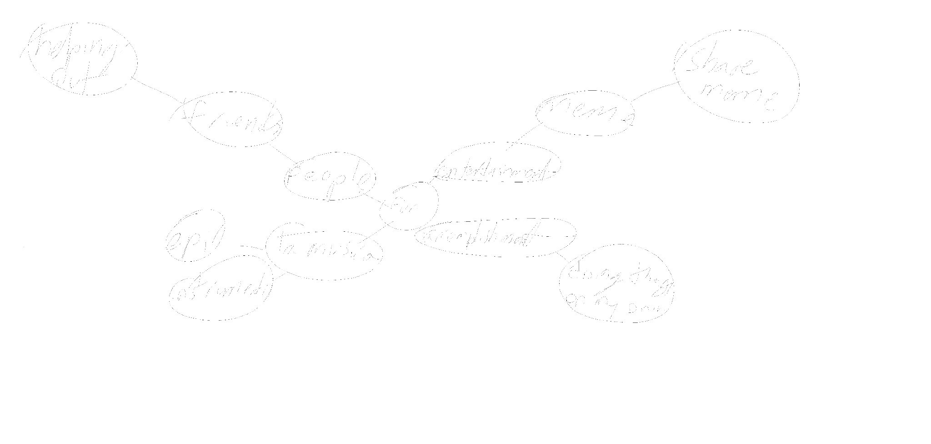
  + Engagement
    - Job description for cleaning
      * We need someone who has experience cleaning and sanitizing tables, chairs, whiteboards, etc…
    - 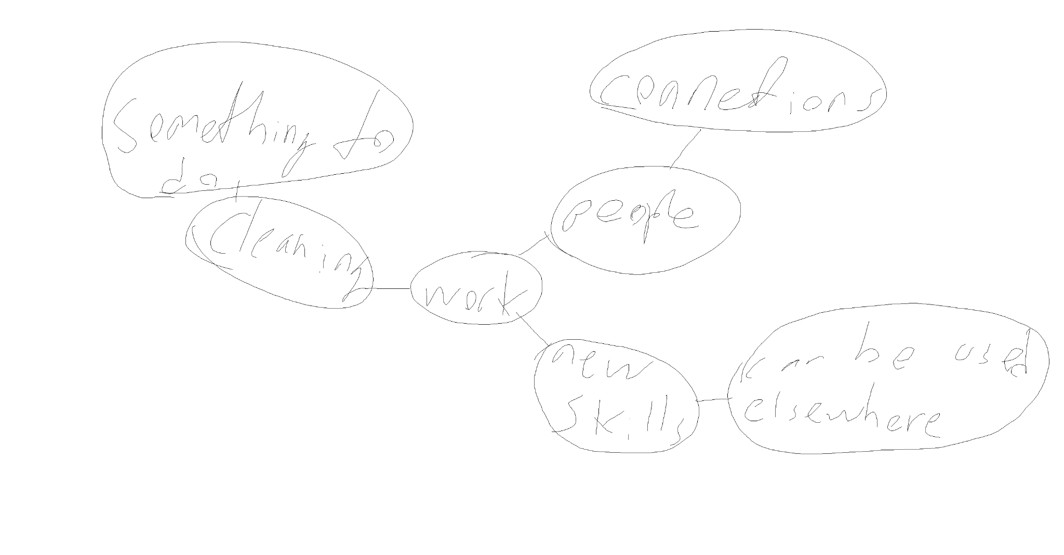
  + Flow
    - Job description for mentor
      * We need someone who can mentor new students. Someone who knows the campus and how to make relationships with new people and help them feel welcome.
    - 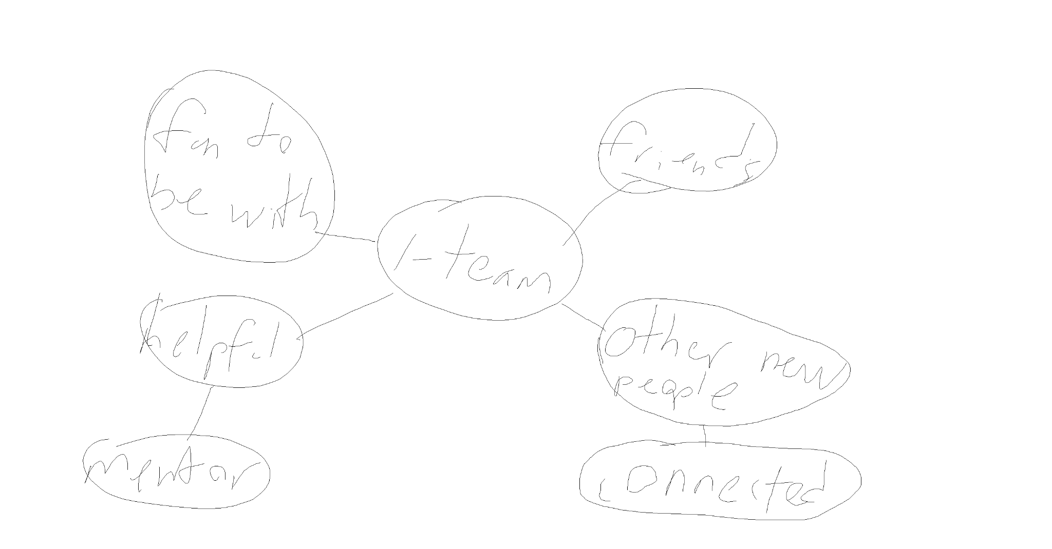
* Odyssey plans
  + Plan 1 - My cool odyssey plan
    - year 0: Succeed in classes
    - year 1: Succeed in classes and maybe married
    - year 2: Succeed in classes and hopefully definitely married
    - year 3: have job that relates somewhat to what I studied.
    - year 4: Don’t be fired.
    - year 5: make money
  + Plan 2 - A cool backup odyssey plan
    - 0: Figure out how to become Norwegian translator certification
    - 1: Find a job with that!
    - 2: Learn japanese
    - 3: Don’t be fired from job
    - 4: Make money
    - 5: maybe use my other skills to do something else
  + Plan 3 - the supreme odyssey plan
    - 0: invest in something
    - 1: get lambo
    - 2: buy some company
    - 3: gain more education
    - 4: work a bit
    - 5: hopefully be financially stable
  + Questions
    - Plan 1
      * How do I know if I will succeed classed in the future?
      * What will I do if I dont?
    - Plan 2
      * What if becoming a translator is a lot harder than I thought?
      * What is a good way of learning Japanese?
    - Plan 3
      * What to invest in?
      * How much is a lambo?
      * What company would be good to buy?
  + Dashboard gauge
    - Plan 1
      * Resources: 90%
      * Likability: 100%
      * Confidence: 95%
      * Coherence: 100%
    - Plan 2
      * Resources: 100%
      * Likability: 20%
      * Confidence: 5%
      * Coherence: 69%
    - Plan 3
      * Resources: 5%
      * Likability: 80%
      * Confidence: 3%
      * Coherence: 10%